**HOSPITAL INFORMATION SYSTEM**

**A Mini Capstone Project**

**Proposal Presented to the**

**Faculty of the**

**Information and Communications Technology Program**

**STI College Program**

**In Partial Fulfillment**

**Of the Requirements for the Degree**

**Bachelor of Science in Computer Engineering**

**Cal, Efren Jr. M.**

**Del Rosario, John Einfrey M.**

**Guevarra, Patrick P.**

**Magno, Kara Caitlin E.**

**San Jose, Brent Louis M.**

**Tan, Vincent Gabriel B.**

**Tanglao Jr., Jower L.**

**Torres, Glaize Anne S.**

**June 2023**

**EXECUTIVE SUMMARY**

**Research Title:** Hospital Information System

**Researchers:** Cal, Efren Jr. M., Del Rosario, John Einfrey M., Guevarra, Patrick P., Magno, Kara Caitlin E., San Jose, Brent Louis M.,Tan, Vincent Gabriel B., Tanglao Jr., Jower L., Torres,

Glaize Anne S.

**Degree:** Bachelor of Science in Computer Engineering

**Date of Completion:** June 2023

**Keyword:** Information System, Management, Hospital, Patient, Staff

With the use of technology, healthcare has evolved into a more efficient facility in terms of information systems. Transition from manual to digital forms has made professionals work effectively. With the objective of replicating and developing a system with goals and challenges in mind, this paper resulted in a system program for patients and staff used by staff only. It aids in the automation of numerous administrative and clinical procedures, including patient admission, discharge, and the storage of patient data or histories.

**ACKNOWLEDGEMENT**

First and foremost, the researchers are grateful to The Almighty God for giving us the knowledge and strength through the entire process. Researchers affiliated with this paper attribute this accomplishment to Almighty God.

Researchers would also like to express sincere gratitude to Mr. Joshua Mendoza, Mini Capstone Advisor, for his guidance throughout the duration of this research project.

Additionally, extended heartfelt appreciation to peers and fellow students for their assistance in successfully completing this research.

Lastly, deepest thanks to the parents and guardians of the researchers for the encouragement and constant support, as this would not have been possible without them.

**TABLE OF CONTENTS**

Title page ………………………………………………………………………………… I

Executive summary ……………………………………………………………………… II

Acknowledgement ………………………………………………………………………. III

Table of Contents ………………………………………………………………………… IV

List of Figures ……………………………………………………………………………. V

List of Notations ………………………………………………………………………….. VI

Introduction ………………………………………………………………………………... 1

Project Context …………………………………………………………………….. 2

General Problem …………………………………………………………………… 3

General Objectives …………………………………………………………………. 3

Scope and Limitations ……………………………………………………………… 4

Review of Related Literatures ……………………………………………………………… 5

Foreign Literatures …………………………………………………………………..5

Local Literature ……………………………………………………………………...7

Appendices ………………………………………………………………………………….11

Appendix A: References ……………………………………………………………11

Appendix B: Flow Chart ……………………………………………………………12

Appendix C: Data Flow Diagram …………………………………………………..13

Existing Context Diagram…………………………………………………...13

Proposed Context Diagram………………………………………………….14

Appendix D: Curriculum Vitae ….…………………………………………………..15

Appendix E: Syntax and Output ….………………………………………………....31

**LIST OF FIGURES**

Figure Name Page

Figure 1 ……………………………………………………………………………….12

Figure 2 ……………………………………………………………………………….13

Figure 3 ……………………………………………………………………………….14

Figure 4 ……………………………………………………………………………….31

Figure 5 ……………………………………………………………………………….32

Figure 6 ……………………………………………………………………………….33

Figure 7 ……………………………………………………………………………….34

Figure 8 ……………………………………………………………………………….35

Figure 9 ……………………………………………………………………………….36

Figure 10 ……………………………………………………………………………….37

Figure 11……………………………………………………………………………….38

Figure 12 ……………………………………………………………………………….39

Figure 13……………………………………………………………………………….40

Figure 14……………………………………………………………………………….41

**LIST OF NOTATIONS**

Definition of Terms:

**Information system** – set of components used collecting, storing, and processing data.

**Staff** – a person employed inside an organization or facility.

**Management** – the process of dealing or controlling.

**Patient** – a person receiving medical attention.

**CHAPTER 1**

**INTRODUCTION**

With the technology advancing through the years of continuous development, various organizations and establishments opted to use technologies to handle the high demands of the increasing population. As web-based technology offers many online services in almost every field, healthcare is no exception to this. Hospitals known for customer services, providing healthcare, and inventory management for a wide range of the population, however it represents a significant obstacle in services and management in terms of efficiency, organization, and the overall flow of work. According to a study conducted by Balaraman & Kosalram (2013), with the varied ways to assess the performance of services specifically a hospital, hospital information systems play a crucial role.

As healthcare and technology evolve the use and implementation of online management or information systems to hospitals provides solutions to easier transactions and rooming, patient and staff security measures, efficient inventory management, reduced medical errors and improved precisions, and overall improve patient care, which benefits institutions, professionals, and patients alike. Moreover, transitioning from paper-based records to digital formats, hospital professionals can securely store, retrieve, and update information, enabling a more efficient, cost effective, and organized facility.

**PROJECT CONTEXT**

Hospitals are institutions that provide healthcare services for their wide range of patients. Addressing specific healthcare challenges in a community or population by improving patient outcomes and expansion of new technologies. In recent years, a more efficient way of information system has been implemented.

The primary objective of this research project is to replicate an existing information system in a hospital and develop a system to address the following challenges and/or requirements:

1. Data Analysis and Reports: The Hospital Information System records and generates the information listed by the hospital staff.
2. Data Privacy and Security: The data registered by the hospital staff are more secure using the Hospital Information System rather than the manual information handling.
3. Proper Discharge: The system enables to easily discharge patients from the system.

The hospital management or information system that handles all the patient information enables the hospital to proper and efficient facilities.

.

**GENERAL PROBLEM**

The efficient management and arrangement of patient data and healthcare information within a hospital or healthcare organization is a general problem that a Hospital Information System (HIS) aims to solve. It aids in the automation of numerous administrative and clinical procedures, including patient admission, discharge, and the storage of patient data or histories.

Implementing a hospital information system can promote operational effectiveness, improve patient care, strengthen data security, and support informed decision-making, all of which can contribute to more efficient and long-lasting healthcare delivery.

**GENERAL OBJECTIVE**

An advanced technological system named a hospital information system (HIS) enables hospitals to manage patient information. It can be seen as a system that enables all hospital departments to efficiently handle their information so they can perform their duties.

**SCOPE AND LIMITATIONS**

**Scope**

This paper undertakes a thorough investigation of how various stakeholders, such as employees, patients, and their relatives and caregivers, are affected in terms of their experience, workflow, and engagement. It also evaluates the effectiveness of measures and safeguards integrated into hospital information systems, while assessing the satisfaction and usability of these systems from the viewpoints of employees and patients.

**Limitations**

This study is limited to only the viewpoint of the hospital staff, specifically the doctors and nurses. It is also limited to only a few functions with the focus of patients, functions are admitting, discharging, and displaying of patient’s information.

The program being limited to the use of a console, it is not applicable to any mobile or computer application. Program execution is also limited to only one run through, the program will no longer display patients previously listed once the program is exited by the user.

**CHAPTER 2**

**REVIEW OF RELATED LITERATURE**

This chapter discusses the related literatures; foreign and local, which systems served as guidance for building of this project.

**FOREIGN LITERATURE**

**Hospital Management System**

According to Anpan et al. (2020) web-based platforms make many medical/hospital procedures online using the Web, as this will help in management of patients, managing of schedules, maintaining the records of patients accessible throughout the hospital. Research represented with requirements and then conducted using various object-oriented programming languages like .net, C#, HTML, and CSS, that will provide the latest technology required to develop. In this research, it is proposed and conducted using four modules, Admin, Doctor, Sister, and Employee in which modules have different functions. Information System that allows the doctors and patients to easily access their records and reports.

With a motivation to make easier, fast, and effective transactions for patients and staff alike. Traditional approach according to this paper has a lengthy process however with proposed Hospital Management System it will help reduce manual efforts, time, and costs.

**E –Hospital Management & Hospital Information Systems – Changing Trends**

Hospital information systems are highly desired to fulfill the requirements of a growing population while simultaneously helping the active healthcare professionals, as well as medical support personnel with great accuracy and promptness. There are several metrics available to evaluate the effectiveness of services to the hospital sector. The use of hospital information systems is essential. It has strongly impacted the business and service delivery models of today ‘s global environment. E-Hospital Management Systems provide the benefits of streamlined operations, enhanced administration and control, and superior patient care. Various software programs that are integrated into HIS collect data in particular hospital departments and manage the patient’s data. Considering the various HIS definitions, HIS is a considerably large area since it includes services addressing various departments, workers, and, lastly, serving the patient's needs in the true sense. Hospital Information Systems (HISs) are supposed to make the right information and knowledge available to the right people, in the right place, at the right time and in the right form.

**RFID System for Quality Healthcare**

RFID technology is used in the patient experience, access control, and asset tracking areas of healthcare. RFID also can provide real-time data for decision-making assistance and speed up the construction of a complex healthcare facility known as a "smart hospital," which is run by a dependable and secure smart hospital management information system (SHMIS). Using this technology, hospitals are given the ability to exercise dynamic control over a variety of entities and streamline operational workflows while minimizing potential dangers to patients and staff.

**LOCAL LITERATURE**

**The impact of computerization of the nutrition support process on the nutrition support program in a tertiary care hospital in the Philippines: Report for the years 2000–2003**

To improve hospital health care delivery by identifying malnutrition in all admitted patients and following up those identified to be malnourished and “at risk of developing malnutrition” a hospital nutrition support program based on the JCAHO system was initiated in 1999. Two major problems were encountered: first, the inability to perform a nutrition surveillance process due to failure by the staff to implement existing nutrition screening tools and second, the lack of awareness and support from the medical staff in this initiative. Two solutions were implemented in 2000: computerization of the nutrition screening and nutrition support process and synchronizing this with the whole nutrition support program. A computer program was developed which performs BMI-based nutrition screening, produces lists of all malnourished patients, and computes the different formulas for either nutritional requirement or parenteral and/or enteral formulation. It also generates patient status reports based on encoded data from the nutrition support team, which prioritized these patients for management based on the data output.

From 2000 to 2003, improvement was seen in these areas: entry of height and weight in the patient record increased from 30% to 90%; nutrition surveillance shows nutritional status distribution to be: normal (58%), underweight (9%), overweight (25%), and obese (8%), referrals to the nutrition support team based on the screen notification increased from 37% to 100%, patient coverage by nutrition support services increased from 7374 (38.8%) in 2000 to 11,369 (83%) in 2003, and critical care patients seen increased from 10% in 2000 to 99% in 2003. More improvement is needed in physician response to nutrition support recommendations, which remains low (11.2–24%). Computerization helps to improve nutritional support delivery in the hospital, but more cooperation and support from the medical staff is still needed for better results.

**Health Information System of St. Paul University Philippines**

This research project focused on analyzing the current processes and transactions in the health services of St. Paul University Philippines to gather data for developing a proposed record management system. The goal was to improve the efficiency of the clinic's services, particularly in creating, organizing, retrieving, and updating health information of clients. Interviews were conducted with clinic staff and IT experts, revealing that the existing manual system performed poorly in records management. Therefore, an automated system was proposed and developed, which was pilot tested and evaluated by the participants. The results showed that the proposed system effectively improved the clinic's recording system. The study also emphasized the importance of management information systems in storing and organizing information efficiently, with computer-generated systems being more reliable and convenient. The researcher recommended presenting the proposed system for approval and implementation, conducting user orientation, addressing system limitations, and seeking support for infrastructure. Future research was encouraged to further enhance the system's efficiency through surveys and benchmarking activities.

**Philippine Orthopedic Center Hospital Information System**

Public hospitals in the Philippines are being considered for privatization due to poor management and lack of funds. While privatization may bring in financial support, it risks turning hospitals into profit-driven businesses, deviating from their original purpose. The Philippine Orthopedic Center (POC), a vital public hospital for orthopedic cases, faces challenges with communication and paperwork, leading to delays and lost documents. To address these issues, a hospital information system (HIS) is being developed to streamline interdepartmental communication and automate processes, from patient registration to billing and medical records. The HIS aims to improve data flow, generate accurate patient statements, and provide reports for decision making. The system is currently undergoing testing and is expected to be released in mid-2015.

After an extensive and meticulous design and development process, the Hospital Information System (HIS) has reached a significant milestone as it nears completion. The system has been successfully constructed with the capability to capture comprehensive patient information, ensuring a smooth and efficient flow of data as patients navigate through various transactions within the hospital. Gone are the days of relying on manual calculations for generating patient statements of account; the HIS now automates this process, providing accurate and precise financial summaries. Furthermore, the system generates reports derived from patient records and transactions, serving as valuable input for informed decision-making.

While the HIS has achieved a functional state, it is currently undergoing rigorous testing to address any minor issues or glitches that may have arisen during the development phase. These adjustments and refinements aim to optimize the system's performance and ensure its seamless operation. The anticipated initial release of the HIS is expected to take place in mid-2015, signaling a significant leap forward in streamlining hospital operations and improving overall healthcare service delivery.

**APPENDICES**

**Appendix A: References**

1. User, S. (2015, February 12). International Research Journal of Engineering and Technology (IRJET) - Volume 2, Issue 09 Dec-2015. <https://irjet.org/wp-content/uploads/2015/02/12-17-A-Rivew-of-Smart-Grid-Technology-in-India.pdf>
2. Balaraman, P., & Kosalram, K. (2013). E –Hospital Management & Hospital Information Systems – Changing Trends. <https://j.mecs-press.net/ijieeb/ijieeb-v5-n1/IJIEEB-V5-N1-6.pdf>
3. RFID based smart hospital management system: A conceptual framework. (2014, November 1). IEEE Conference Publication | IEEE Xplore. <https://ieeexplore.ieee.org/abstract/document/7020594>
4. G. Maguire, J. (n.d.-b). HEALTH INFORMATION SYSTEM OF ST. PAUL UNIVERSITY PHILIPPINES. <https://ojs.aaresearchindex.com/index.php/spuprd/article/download/429/81>
5. Ong, J., Chua, J., Go, L., [ ], & Hufano, T. (2013). Philippine Orthopedic Center Hospital Information System. <https://www.dlsu.edu.ph/wp-content/uploads/pdf/conferences/research-congress-proceedings/2015/FNH/017FNH_Ong_JMS.pdf>
6. Llido, L. O. (2006). The impact of computerization of the nutrition support process on the nutrition support program in a tertiary care hospital in the Philippines: Report for the years 2000–2003. Clinical Nutrition, 25(1), 91–101. <https://doi.org/10.1016/j.clnu.2005.08.006>

**Appendices B: Flow Chart**

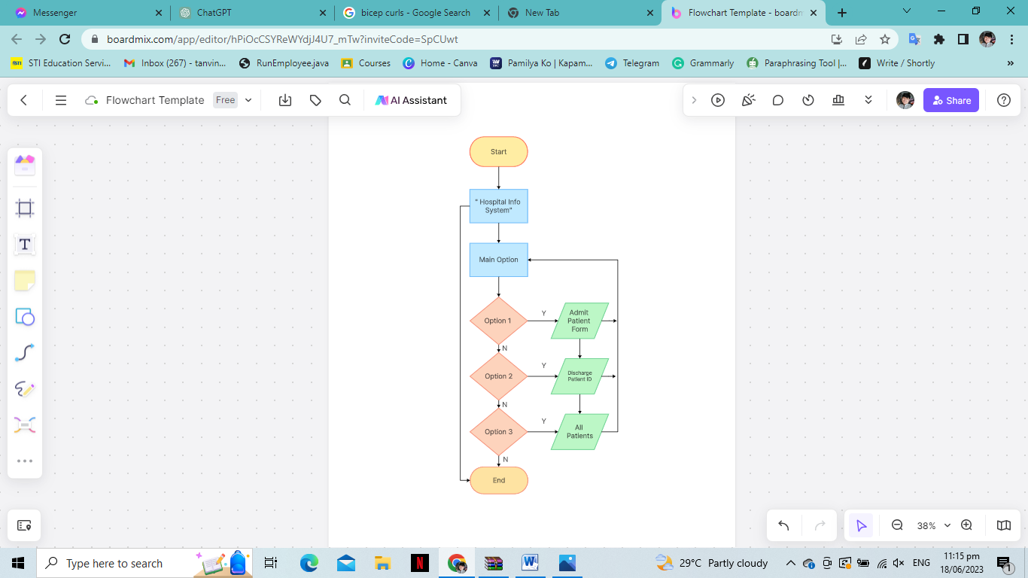

Figure 1.

**Appendices C: Data Flow Diagram**

**Existing Context Diagram**

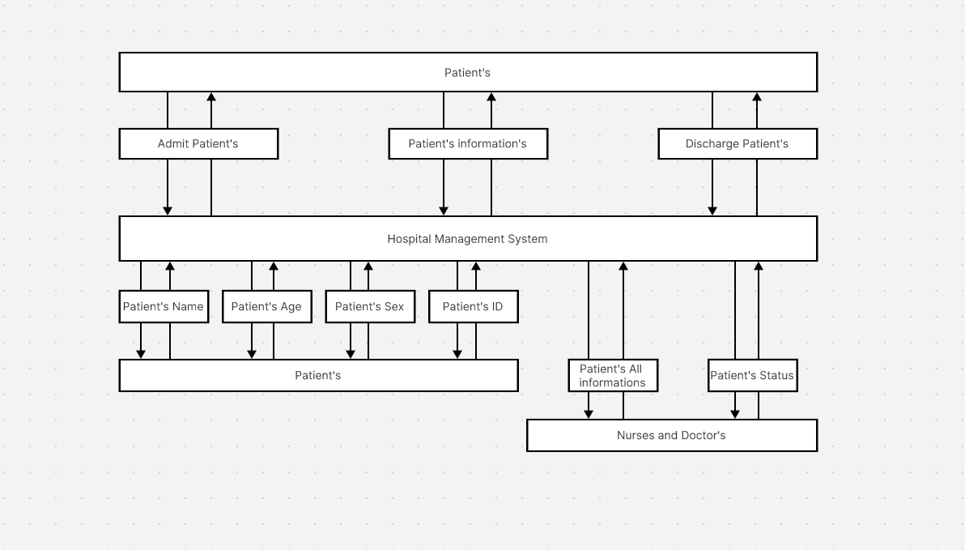

Figure 2.

**Proposed System Diagram**

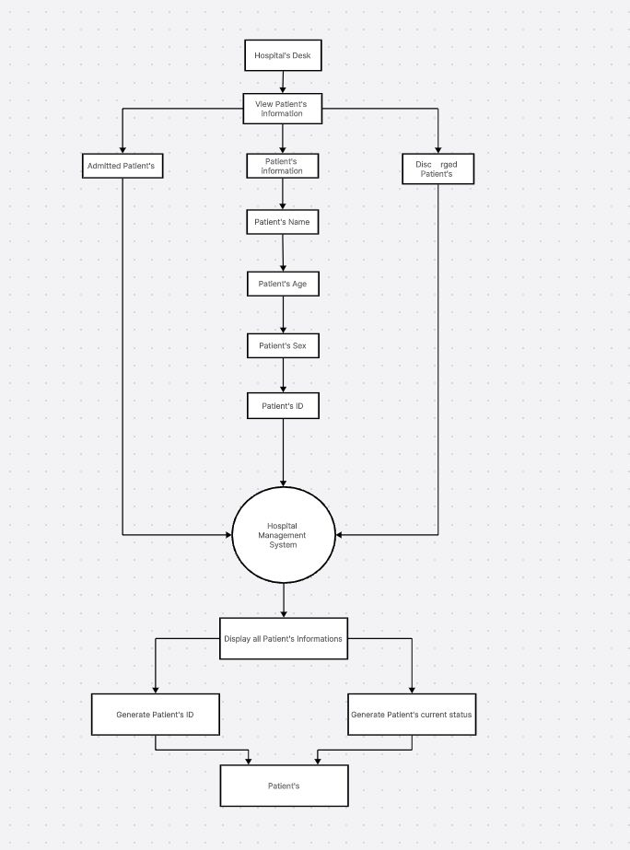

Figure 3.

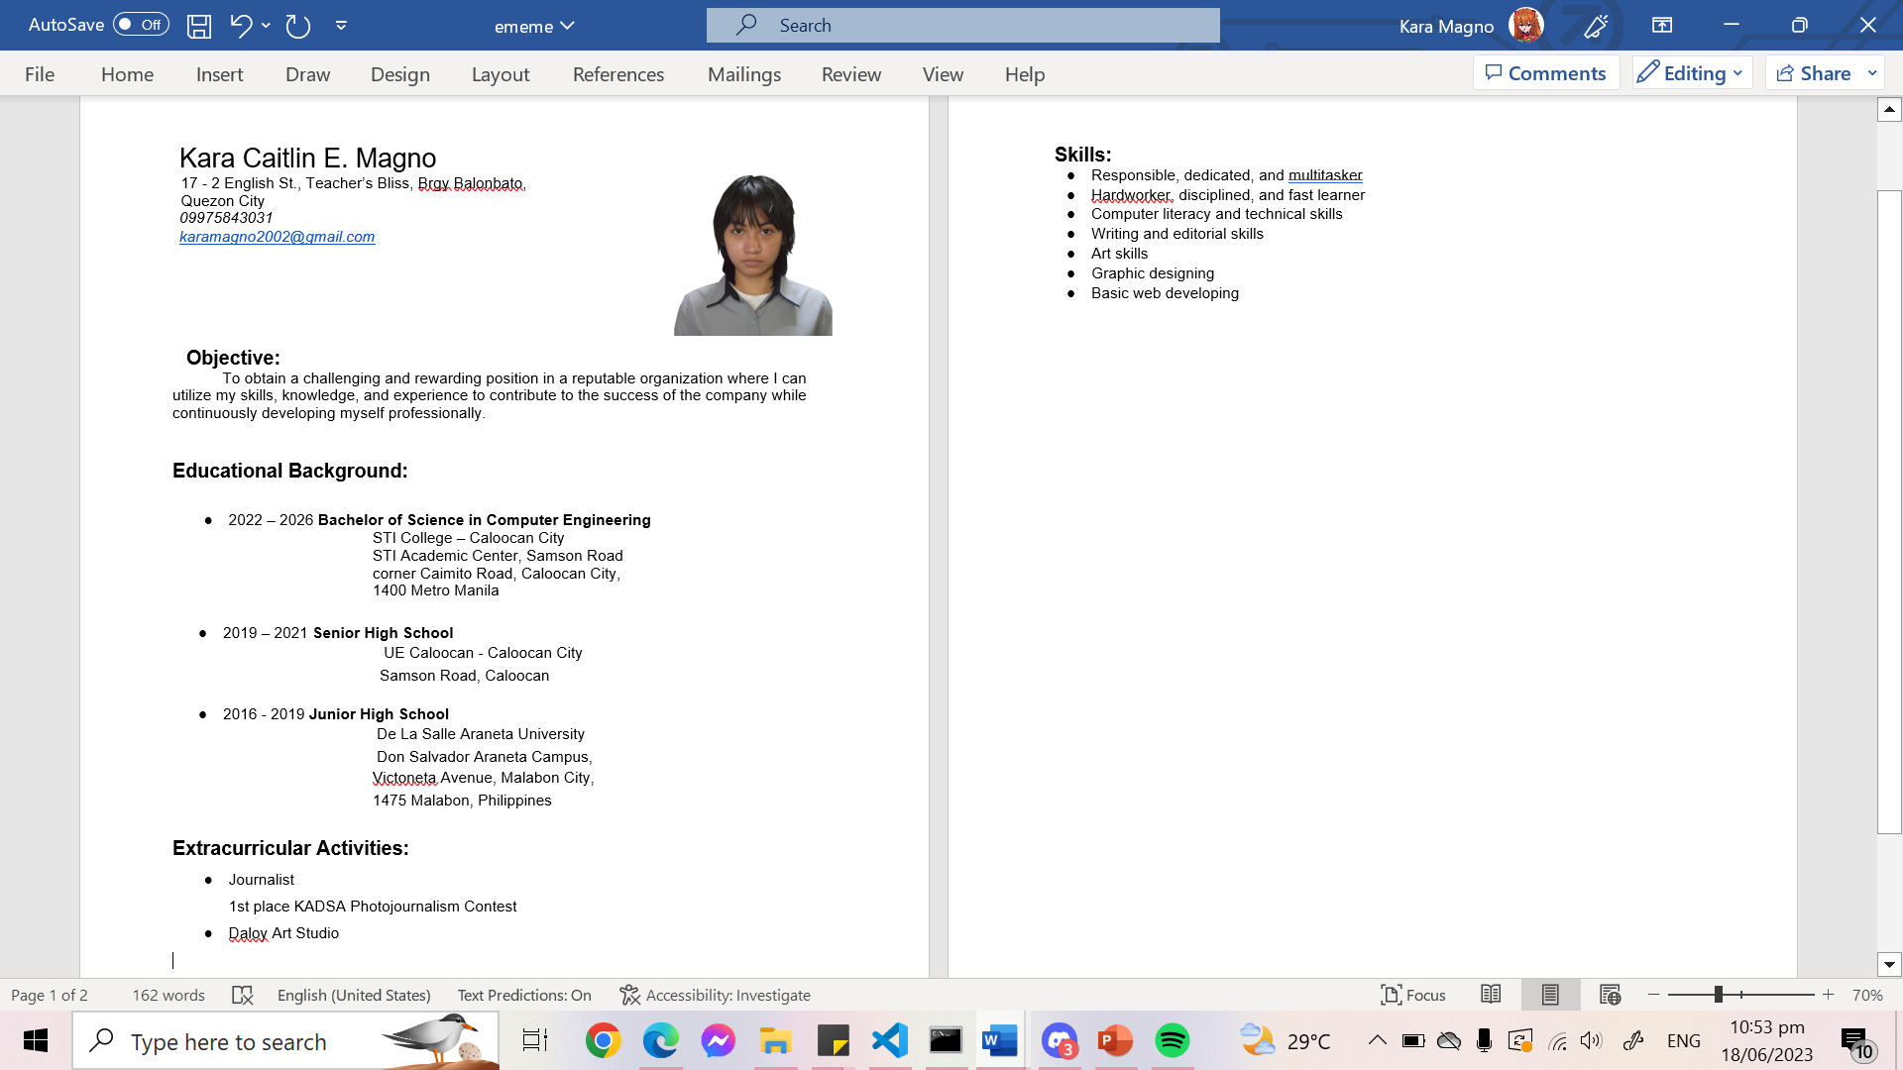**Appendices D: Curriculum Vitae**

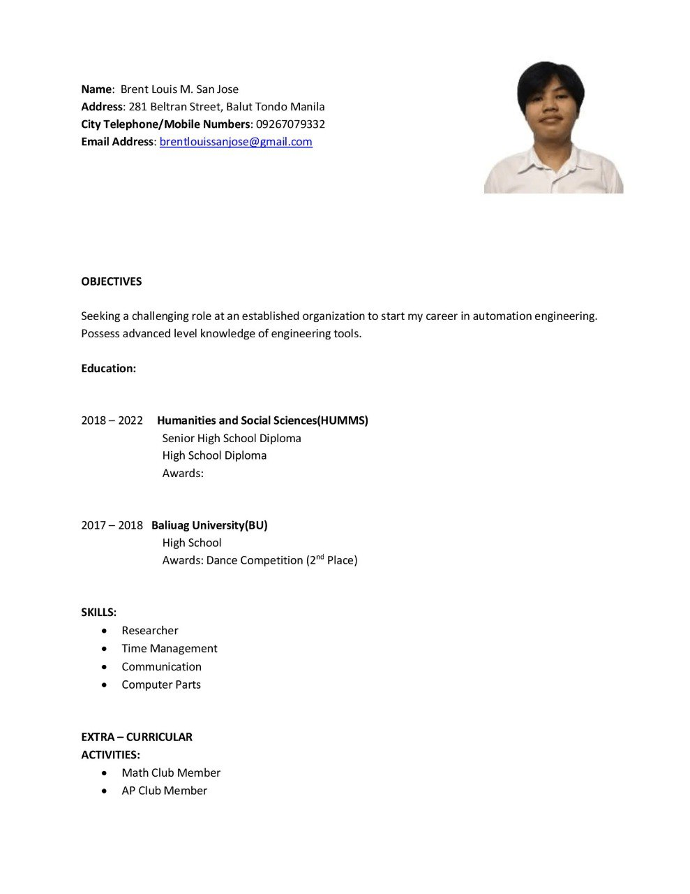

**Appendices E: Syntax and Output**

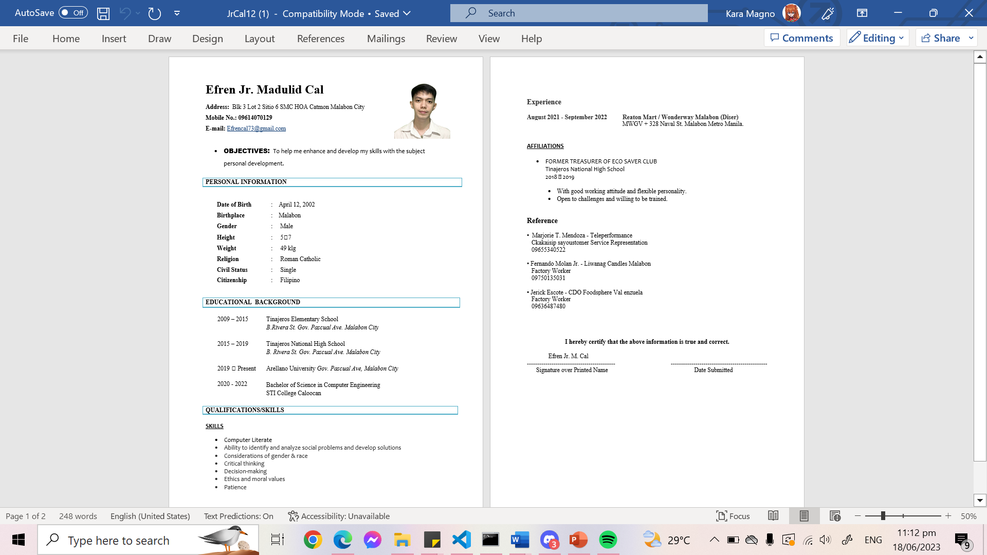

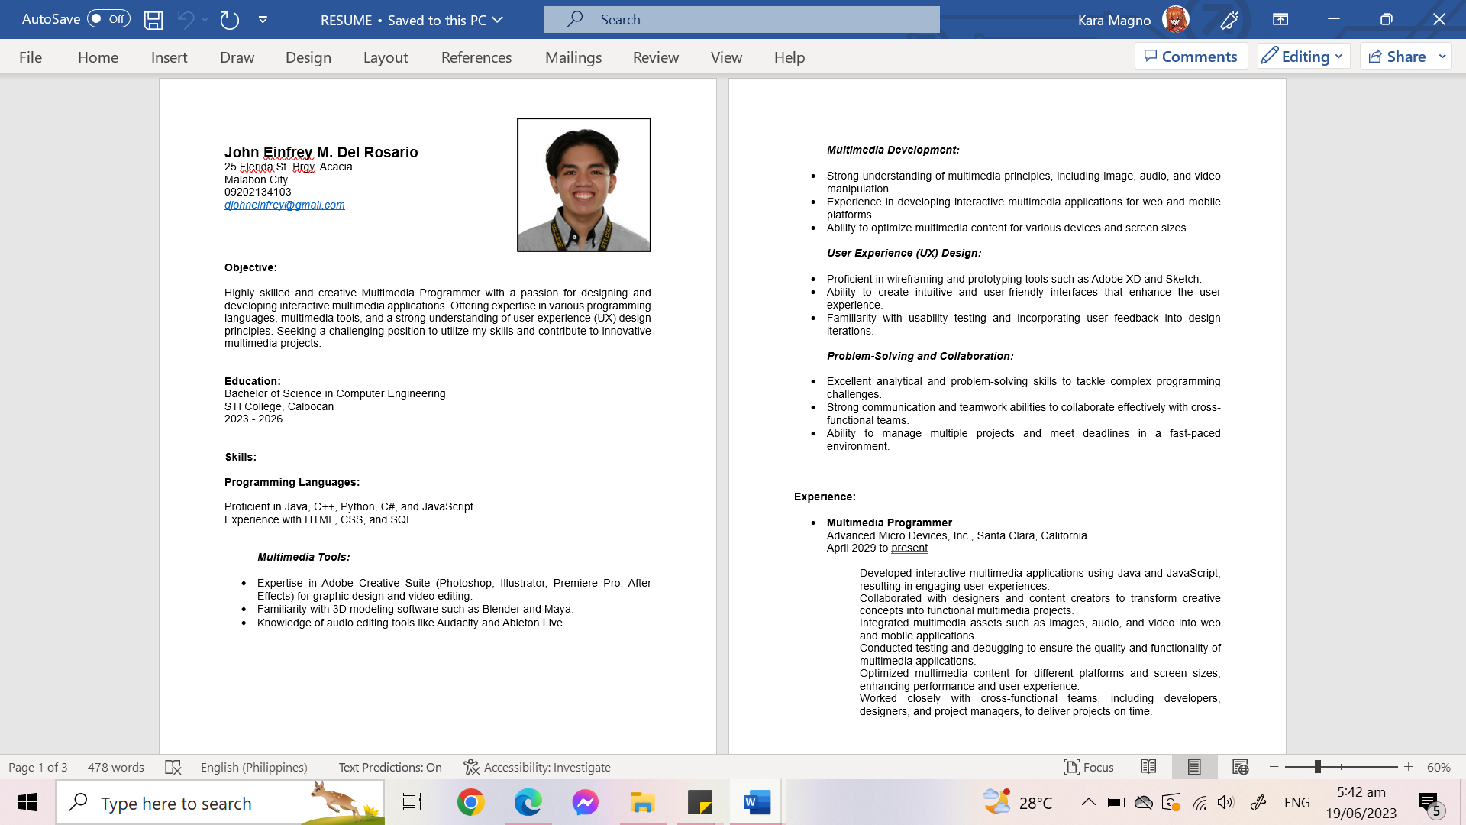



**Appendices E: Syntax and Output**

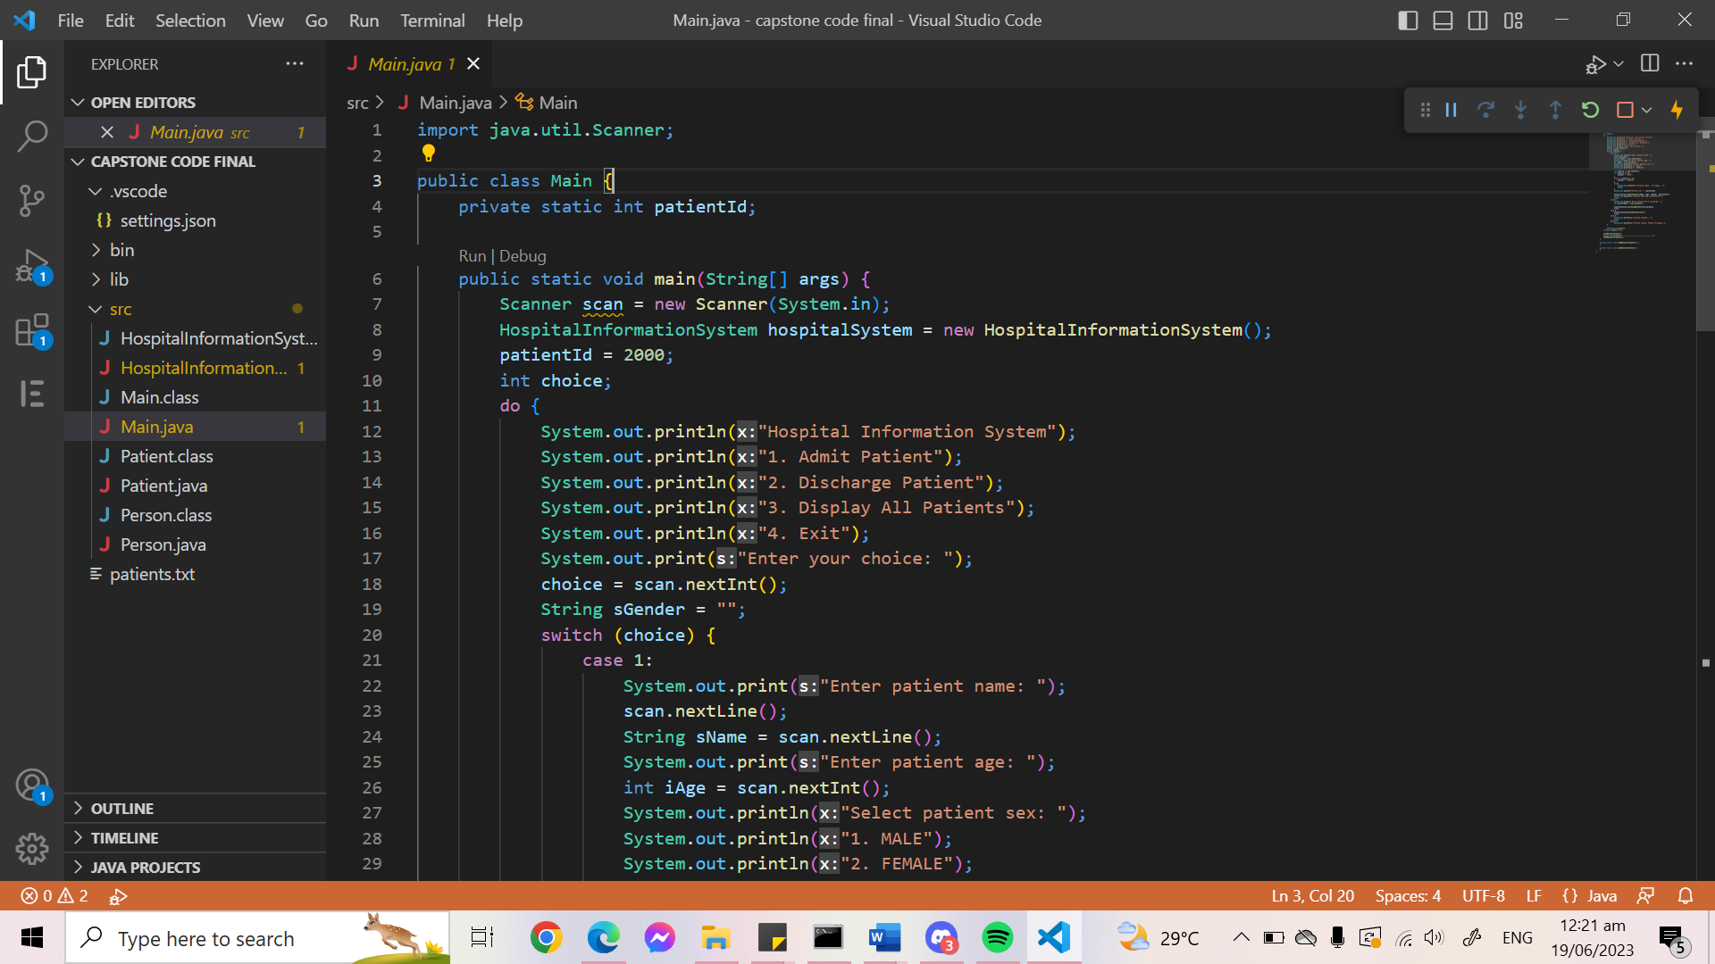

Figure 4.

Figure 5.

Figure 6.

Figure 7.

Figure 8.

Figure 9.

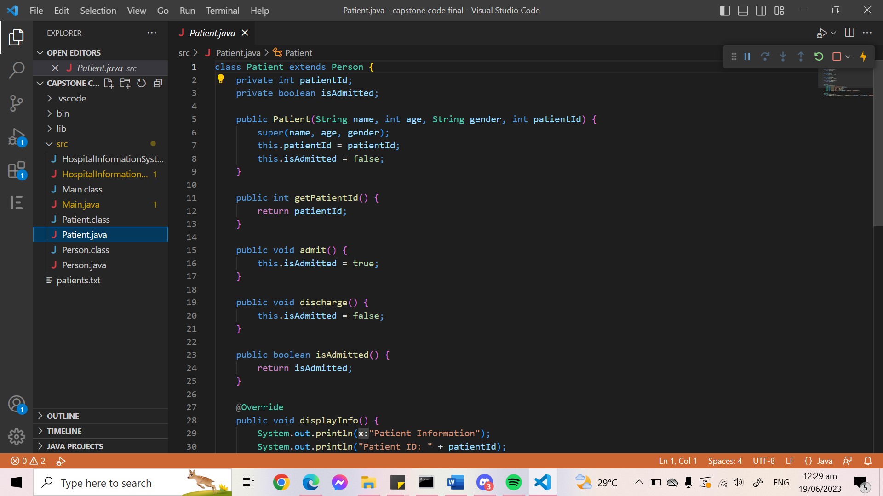

Figure 10.

Figure 11.

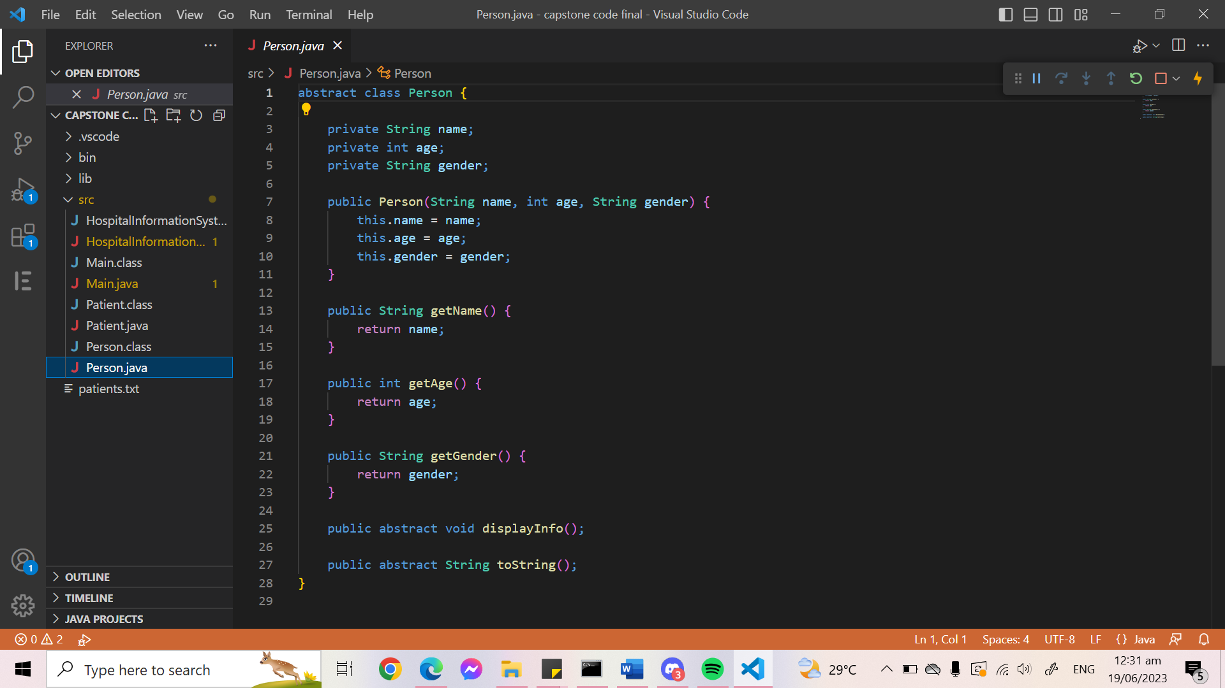

Figure 12.

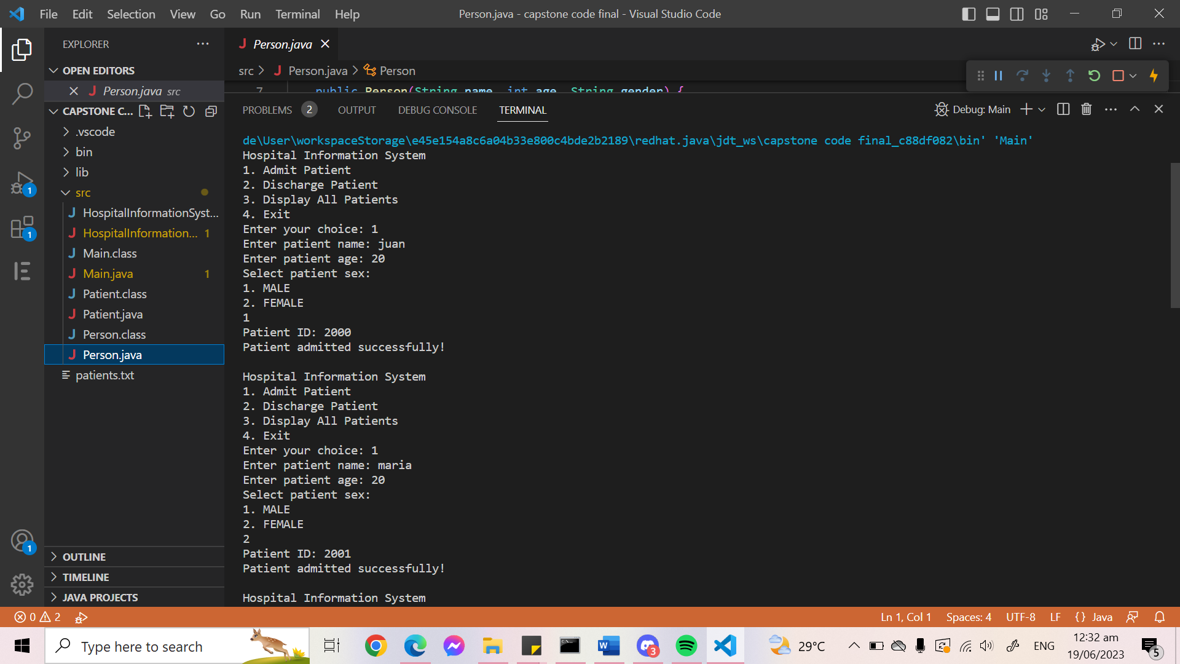

Figure 13.

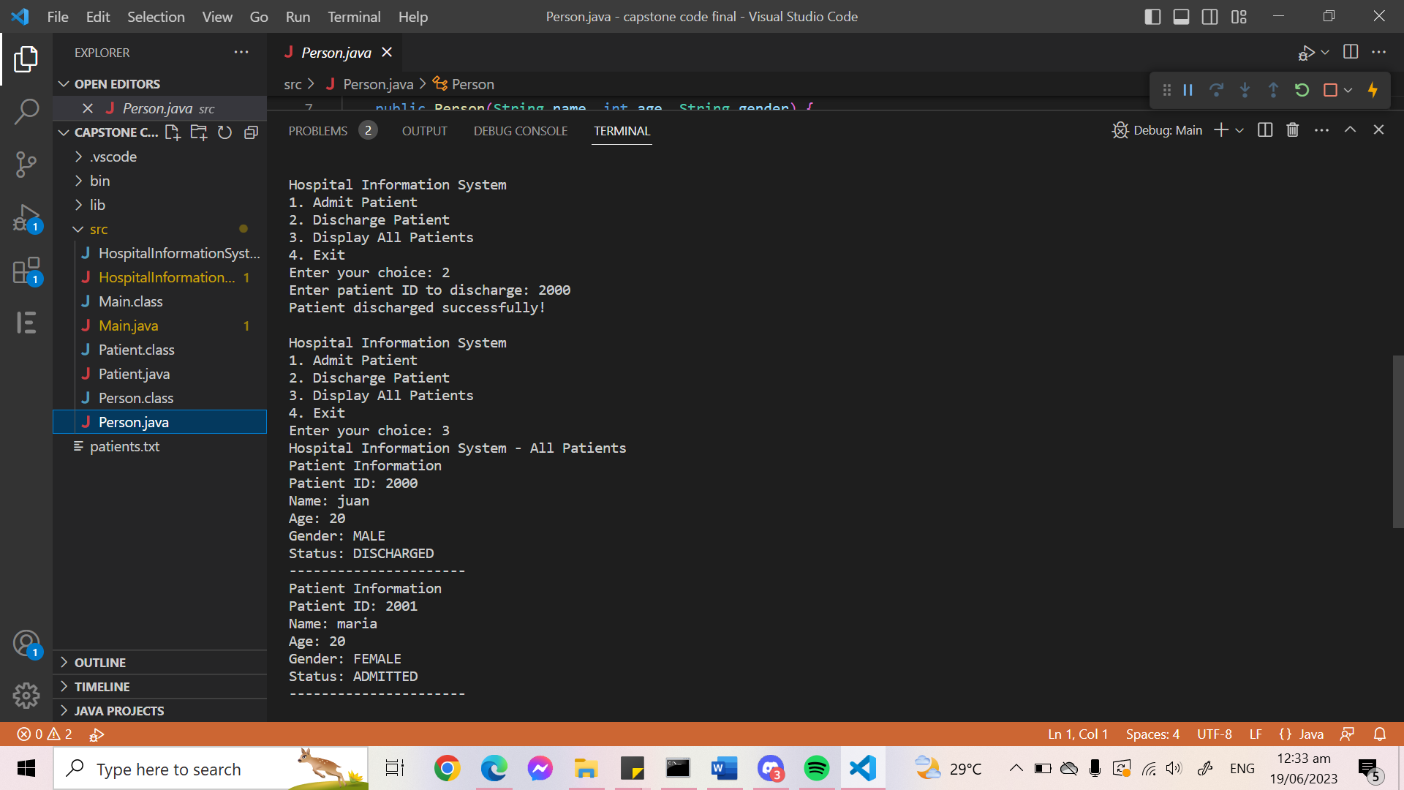

Figure 14.